INFO 7390

Advances in Data Sciences and Architecture Assignment 1

Student Name: ______Zixuan Yu_________________________ Professor: Nik Bear Brown

Due: Sunday May 20, 2018

Q1 (5 Points) How many people must there be before the probability that at least two people have a birthday on October 3 is greater than 1/2?

Answer1(calculate at least 2 persons on 10.3)：613

Answer2(assure 1 people has born on 10.3): 253

Q2 (5 Points) Write python code to simulate question 1.

1.

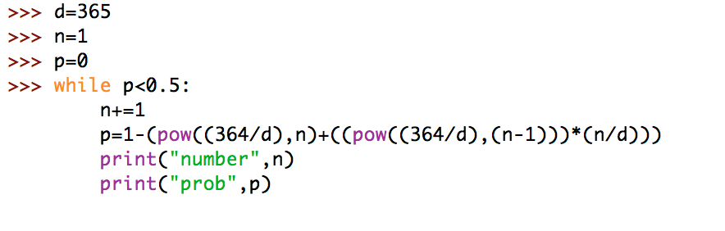

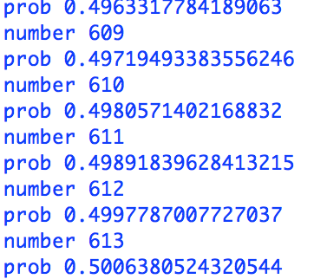

2.

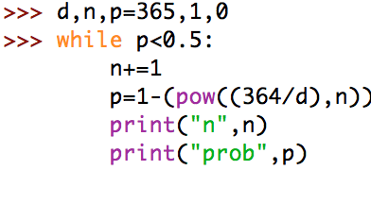

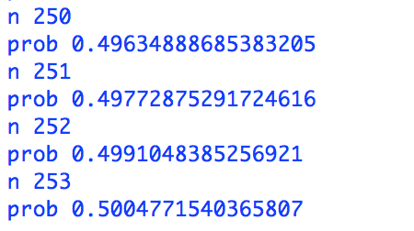

Q3 (5 Points) What is the probability of getting exactly 2 heads after flipping three coins?

Answer：3/8

Q4 (5 Points) Write python code to simulate question 3.



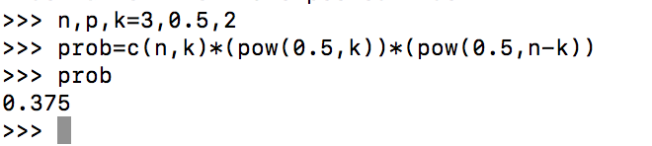

Q5 (5 Points) Consider a six-sided die that gets a 1 with probability p = 1/6. What is the probability that you can get a 1 after rolling the die 3 times? What is the probability of getting exactly one success (a roll of 1) in three tries?

Answer1: 1/6

Answer2:75/216

Q6 (5 Points) Write python code to simulate question 5.

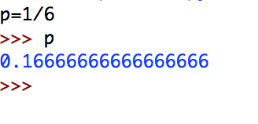



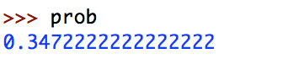

Q7 (5 Points) Suppose the MTV Video Music Awards allows users to vote for the following for “video of the year.”

1. Miley Cyrus - "Wrecking Ball" (https://www.youtube.com/watch?v=My2FRPA3Gf8 )
2. Iggy Azalea- "Fancy" (https://www.youtube.com/watch?v=O-zpOMYRi0w )
3. Brad Paisley - "The Ballad Of Honey Boo Boo" (https://www.youtube.com/watch?v=11Uq3iGESYM )

Of those making deliberate votes 50% would vote for Brad Paisley - "The Ballad of Honey Boo Boo," 30% for Miley Cyrus - "Wrecking Ball" and 20% for Iggy Azalea- "Fancy." However, 25% of voters are lazy and just click one of the three options with equal probability.

1. Let M be a random variable that represents the expected votes for Miley Cyrus - "Wrecking Ball"
2. Let I be a random variable that represents the expected votes for Iggy Azalea- "Fancy"
3. Let B be a random variable that represents the expected votes for Brad Paisley - "The Ballad Of Honey Boo Boo"

Calculate M, I and B. Show your work.

Answer： M:30.8%

I: 23.3%

B:45.8%

Q8 (5 Points) Write python code to simulate question 7.

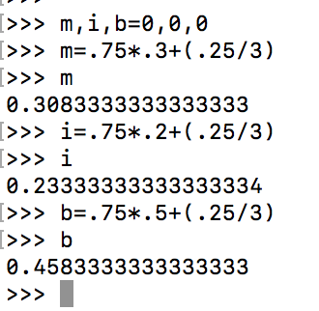

Q9 (5 Points) Suppose you're on a game show, and you're given the choice of n doors: Behind one door is a million dollars; behind all the others, donuts. You pick a door, say No. 1, and the host, who knows what's behind the doors, opens another door, say No. 3, which has a donut. He then says to you, "Do you want to another door?"

(1 Point) Is it to your advantage to switch your choice? Assume k of the n doors are revealed:

Answer: Yes

 (2 Points) What is the probability of getting the million-dollar door if you stay?

Answer: 1/N

(2 Points) What is the probability of getting the million-dollar door if you switch to another non- revealed door?

Answer: N-1/(N*(N-K-1))

Q10 (5 Points) Write python code to simulate question 9.

